**Module 3 Lesson 2:**

**Evaluating Trigonometric Functions and**

**The Unit Circle**

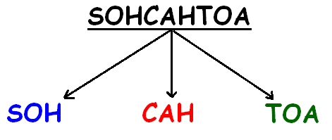

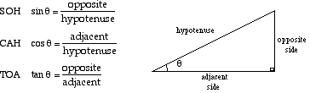

Learning Targets:

I can find the exact value of the three basic trigonometric functions (sine, cosine, tangent) using the special right triangles.

I can use the unit circle to find trigonometric values of quadrantal angles.

**How do we find the EXACT values of sine, cosine, and tangent of Angles?**

Steps:

Things to think about: All Students Take Calculus

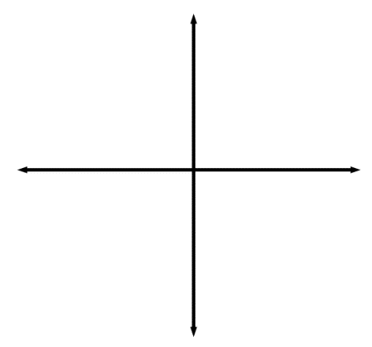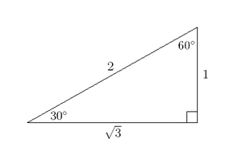

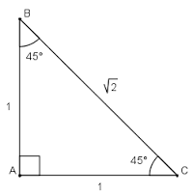

Example: Find the exact value of each of the following.

1. $sin⁡{60}^{o}$ 4. $\cos{{120}^{o}}$
2. $tan{ 210}^{o}$ 5. $\sin{{(-135)}^{o}}$
3. $\cos{{(-45)}^{o}}$ 6. $\tan{{(-315)}^{o}}$

Additional Examples:

1. Angle $θ$ is an angle in standard position and $B(-3,4)$ is a point on the terminal side of the angle. Find the value of $\sin{θ}$.
2. Angle $θ$ is an angle in standard position and $B(-\sqrt{3},1)$ is a point on the terminal side of the angle. Find the value of $\sin{θ}$, $\cos{θ}$, and $\tan{θ}$.
3. In which quadrant does the terminal side of an angle lie if $\sin{θ}>0$ and $\cos{θ<0}$?
4. Given $\sin{θ}=\frac{3}{5}$ and ${90}^{0}<{θ<{180}^{o}}$, find $\cos{θ}$

**How do we find the EXACT values of sine, cosine, and tangent of Quadrantal (90, 180, 270, 360) Angles?**

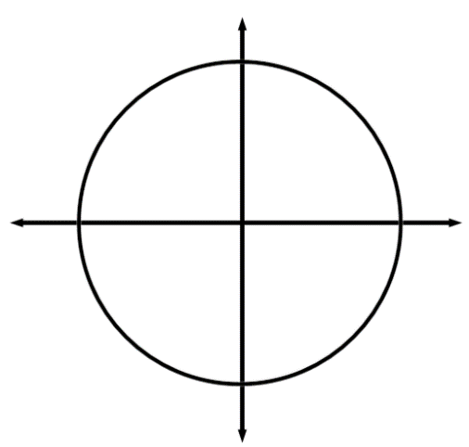**Unit Circle**

A unit circle is shown to the left. Angle θ is a The unit circle has a center at (0,0) and a radius equal to 1.

***cosine*** of angle θ is ALWAYS equal to:

***sine*** of angle θ is ALWAYS equal to:

***tangent*** of angle θ is ALWAYS:

Use the unit circle to find the following trigonometric values.

|  |  |  |  |
| --- | --- | --- | --- |
| $$\sin{0^{o}=}$$ | $$\sin{{90}^{o}=}$$ | $$\sin{{180}^{o}=}$$ | $$\sin{{270}^{o}=}$$ |
| $$\cos{0^{o}=}$$ | $$\cos{90^{o}=}$$ | $$\cos{180^{o}=}$$ | $$\cos{270^{o}=}$$ |
| $$\tan{0^{o}=}$$ | $$\tan{90^{o}=}$$ | $$\tan{180^{o}=}$$ | $$\tan{270^{o}=}$$ |